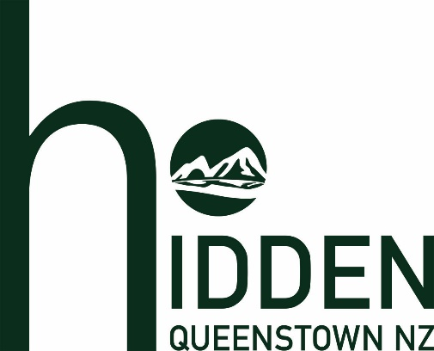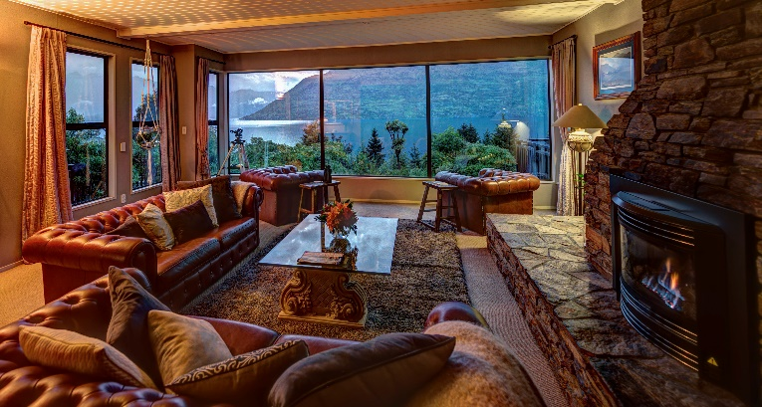

Hidden Lodge – Descriptions
Hidden Lodge is a tranquil haven for guests to relax and enjoy the secluded serenity of Queenstown, New Zealand.
On arrival, guests are mesmerised by commanding views of The Remarkables and Cecil Peak mountains, Hidden Island and Lake Wakatipu.
There are four spacious guest suites, each featuring super-king size beds and sizeable ensuites. Every guest can enjoy the wood-fired hot pool, gymnasium and sauna. The lounge area offers panoramic views while the sun-drenched outdoor courtyard is ideal for relaxation.
The on-site Lodge Manager provides customised, fully-cooked breakfasts for guests. In the evening guests can socialise over canapes and refreshments. The breakfast, canapes and drinks are complimentary as are tea, coffee and soft drinks throughout the day.
At this boutique property there is ample off street parking, high-quality Wi-Fi is free and assistance is available for transport information, restaurant suggestions, activity options and much more.
150 WORDS
Situated only 6km from the heart of Queenstown, Hidden Lodge offers four spacious guest suites and is renowned for its hosted service, provided by our on-site manager.
The views across Lake Wakatipu to Cecil Peak and The Remarkables mountain range are breath-taking.
All suites feature private bathrooms, and the lodge amenities include a wood-fired hot pool, gymnasium and sauna.
Cooked breakfasts, evening canapes and refreshments are all complimentary.
68 WORDS

Hidden Lodge offers guests a relaxing haven for their visit to Queenstown. Views from the Lodge, across Lake Wakatipu and the mountains beyond, are truly spectacular.
The four guest suites each have private bathrooms. Our on-site host provides complimentary breakfasts and, in the evening, canapes accompanied by drinks.
48 WORDS
Queenstown’s Hidden Lodge provides boutique accommodation for up to eight guests in four spacious suites. Our on-site host offers complimentary breakfasts, evening canapes and drinks for your enjoyment.
28 WORDS

