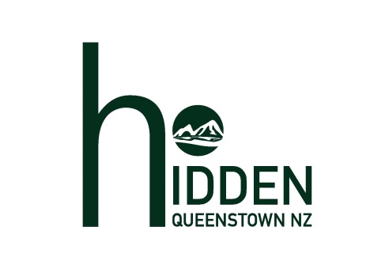
Hidden Lodge – Descriptions
Queenstown’s Hidden Lodge is a haven for guests looking to relax and enjoy the serenity on offer at this secluded location.
On arrival guests are mesmerised by commanding views of The Remarkables and Cecil Peak mountains, Hidden Island and Lake Wakatipu.
There are four spacious guest suites featuring super-king size beds. Each suite has its own bathroom. All guests can enjoy the wood-fired hot pool, gymnasium and sauna. The lounge area offers panoramic views while the sun-drenched outdoor courtyard is ideal for relaxation.
The on-site Lodge Manager provides customised, fully-cooked breakfasts for guests. In the evening guests can meet together for canapes and drinks. The breakfast, canapes and drinks are complimentary as are tea, coffee and soft drinks throughout the day.
At this boutique, high quality accommodation Wi-Fi is free and there is ample off street parking. Assistance is available for transfer information, restaurant suggestions, activity options and much more.
150 WORDS

Situated only 6km from the heart of Queenstown, Hidden Lodge offers four spacious guest suites and is renowned for its hosted service, provided by an on-site manager.
The views across Lake Wakatipu to Cecil Peak and The Remarkables mountain range are breath-taking.
All suites feature ensuite bathrooms and the lodge amenities include a wood-fired hot pool, gymnasium and sauna.
Fully cooked breakfasts and evening canapes with drinks, are complimentary.
69 WORDS

Hidden Lodge offers guests a relaxing haven for their visit to Queenstown. Views from the Lodge, across Lake Wakatipu and the mountains beyond, are truly spectacular.
The four guest suites each have their own bathrooms. Our on-site host provides complimentary breakfasts and, in the evening, canapes accompanied by drinks.
49 WORDS

Queenstown’s Hidden Lodge provides boutique accommodation for up to eight guests in four suites. Complimentary breakfasts, evening canapes and drinks are provided by our on-site host.
26 WORDS

